**MS.NET**

**C:\Users\lilesha\Desktop\Web\Dot Net\Examination Screen_files\I_3_d.jpgC:\Users\lilesha\Desktop\Web\Dot Net\Examination Screen_files\I_5_d.jpg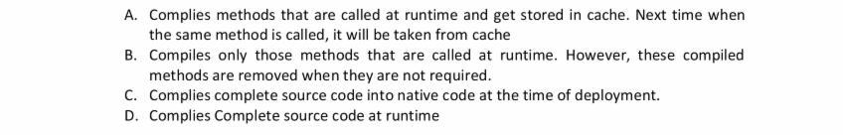C:\Users\lilesha\Desktop\Web\Dot Net\Examination Screen_files\I_7_d.jpg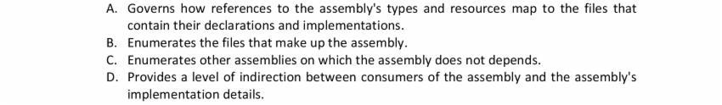C:\Users\lilesha\Desktop\Web\Dot Net\Examination Screen_files\I_11_d.jpgC:\Users\lilesha\Desktop\Web\Dot Net\Examination Screen_files\I_13_d.jpgC:\Users\lilesha\Desktop\Web\Dot Net\Examination Screen_files\I_15_d.jpg**

**C:\Users\lilesha\Desktop\Web\Dot Net\Examination Screen_files\I_17_d.jpg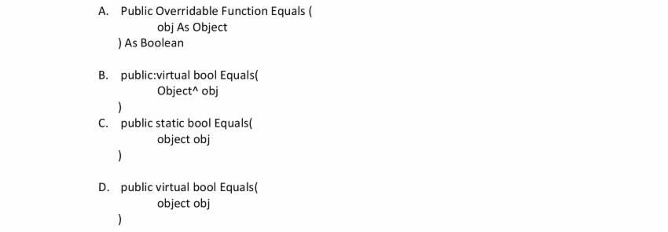C:\Users\lilesha\Desktop\Web\Dot Net\Examination Screen_files\I_19_d.jpgC:\Users\lilesha\Desktop\Web\Dot Net\Examination Screen_files\I_21_d.jpg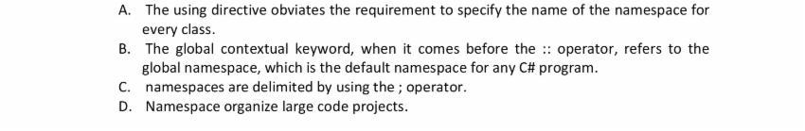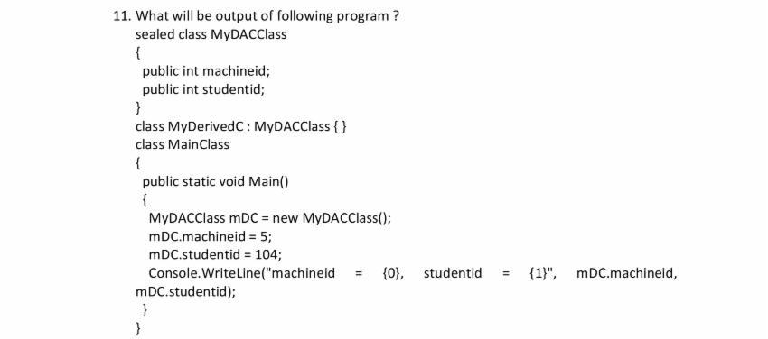C:\Users\lilesha\Desktop\Web\Dot Net\Examination Screen_files\I_25_d.jpg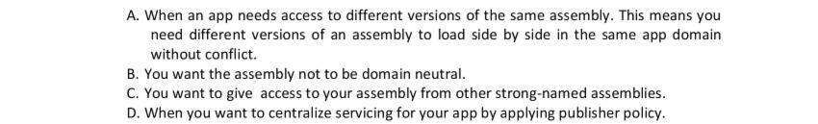**

**C:\Users\lilesha\Desktop\Web\Dot Net\Examination Screen_files\I_27_d.jpgC:\Users\lilesha\Desktop\Web\Dot Net\Examination Screen_files\I_29_d.jpgC:\Users\lilesha\Desktop\Web\Dot Net\Examination Screen_files\I_31_d.jpgC:\Users\lilesha\Desktop\Web\Dot Net\Examination Screen_files\I_33_d.jpgC:\Users\lilesha\Desktop\Web\Dot Net\Examination Screen_files\I_35_d.jpg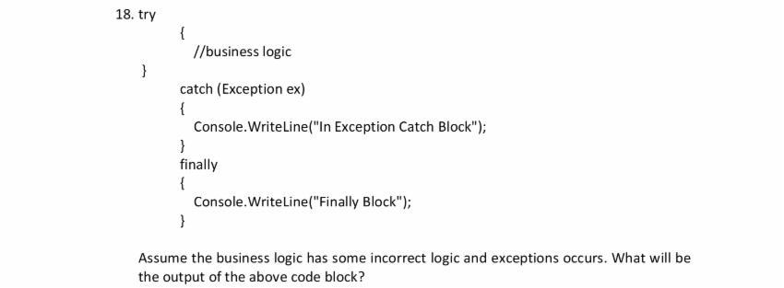C:\Users\lilesha\Desktop\Web\Dot Net\Examination Screen_files\I_39_d.jpg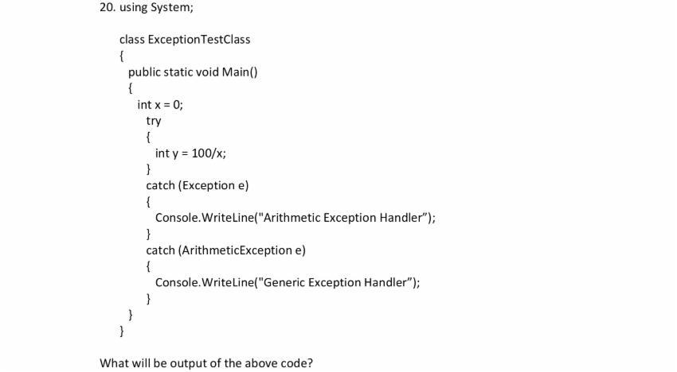C:\Users\lilesha\Desktop\Web\Dot Net\Examination Screen_files\I_43_d.jpgC:\Users\lilesha\Desktop\Web\Dot Net\Examination Screen_files\I_45_d.jpgC:\Users\lilesha\Desktop\Web\Dot Net\Examination Screen_files\I_47_d.jpg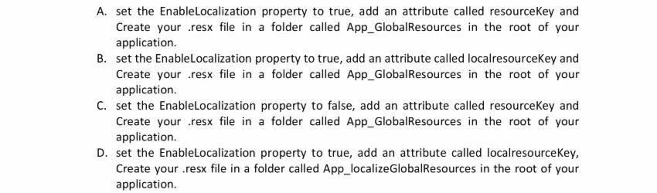C:\Users\lilesha\Desktop\Web\Dot Net\Examination Screen_files\I_49_d.jpg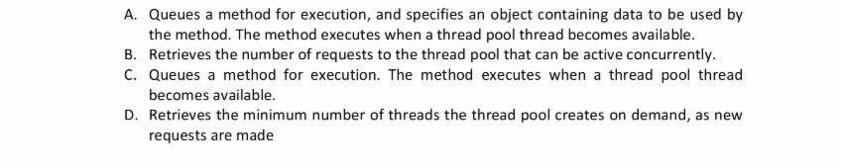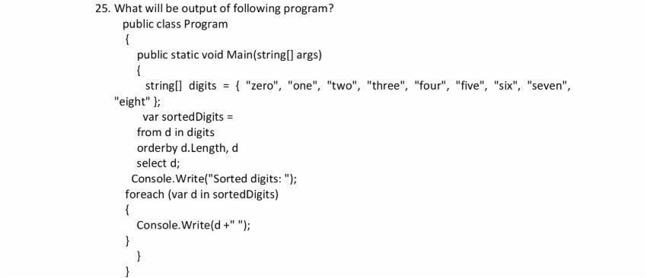C:\Users\lilesha\Desktop\Web\Dot Net\Examination Screen_files\I_53_d.jpg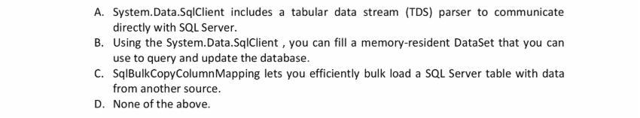C:\Users\lilesha\Desktop\Web\Dot Net\Examination Screen_files\I_55_d.jpg**

**C:\Users\lilesha\Desktop\Web\Dot Net\Examination Screen_files\I_57_d.jpgC:\Users\lilesha\Desktop\Web\Dot Net\Examination Screen_files\I_59_d.jpgC:\Users\lilesha\Desktop\Web\Dot Net\Examination Screen_files\I_61_d.jpg**

**C:\Users\lilesha\Desktop\Web\Dot Net\Examination Screen_files\I_63_d.jpgC:\Users\lilesha\Desktop\Web\Dot Net\Examination Screen_files\I_67_d.jpgC:\Users\lilesha\Desktop\Web\Dot Net\Examination Screen_files\I_69_d.jpgC:\Users\lilesha\Desktop\Web\Dot Net\Examination Screen_files\I_73_d.jpgC:\Users\lilesha\Desktop\Web\Dot Net\Examination Screen_files\I_75_d.jpg**

**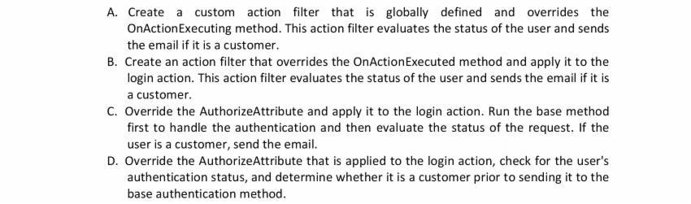C:\Users\lilesha\Desktop\Web\Dot Net\Examination Screen_files\I_79_d.jpgC:\Users\lilesha\Desktop\Web\Dot Net\Examination Screen_files\I_81_d.jpg**